**P5 LESSON NOTES TERM ONE**

**LOCATION OF UGANDA IN EAST AFRICA**

**Regions that make up Uganda.**

Central, Eastern, western, northern, northeast, west nile.

**Districts in Uganda.**

**Northern regions**

Gulu, Amuru, Pader, Kitgum,Arua, Nebbi, Moracha

**Eastern region**

Kamuli, Jinja, Tororo, Budaka.

**Western region**

Masindi, Kiryandonggo, Bushenyi, Mitoma

**Central region**

Kampala, Wakiso, Mukono, Kayunga, Masaka, Kabarole.

**Newly created districts in Uganda.**

Madi okollo district

Obongi district

**Reasons for creating more districts in Uganda.**

* To create more employment opportunities
* To promote development of all areas
* To make administration easy.
* To extend social services nearer to people

**Problems faced by government while creating new districts.**

* Shortage of fund
* Corruption

**Ministry responsible for creating new district**

* It’s under the ministry of local government.

**Location of Uganda on the map of East Africa.**

**SOUTH SUDAN**

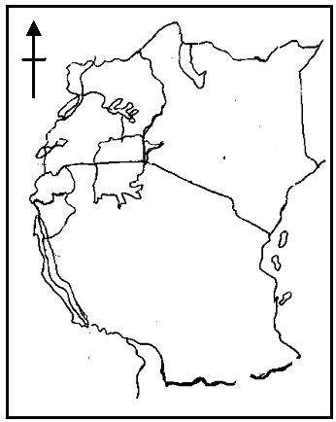

**KENYA**

**UGANDA**

**TANZANIA**

**How to locate Uganda using the lines of latitude and longitude.**

To locate a place is to find its exact position

The method of locating places on a map using lines of latitude and lines of longitude is called grid reference.

Lines of latitude. These are imaginary lines drawn on a map from East to West.

Latitude. It is the distance of a place North or South of the equator.

Lines of longitude is the imaginary line drawn on a map from north to south.

**Examples of lines of latitude**

* Equator 0⁰
* Tropic of cancer 23½⁰N or 23.5⁰N
* Tropic of capricom 23½ ⁰S or 23.5⁰S
* Arctic circle 66½⁰N or 66.5N
* Antarctic circle 66½⁰S or 66.5⁰S

**A Hemisphere.** Is a half of the globe

The globe is spherical in shape.

The equator is called a spherical line of latitude because other lines of latitude are numbered from it.

The sun is over head equator on 21st March and 23rd September.

**Equninox** is the period of the year when the sun is overhead the equator.

**Lakes crossed by the equator in Uganda**

* Lake George
* Lake Victoria

**Districts crossed by the equator in Uganda**

Kasese, Ibanda, Sembabule, Wakiso, Mpigi

**Uses of lines of latitude/latitudes**

* They determine the climate of a given area
* They locate places on a map

**Use of lines of longitude**

* They help to determine time
* They determine dates using the international dateline.
* They locate places on the map.

**Ways of locating different places**

* Use of latitude and longitudes/ grid reference.
* Use of a compass direction
* Use of a land mark
* Use of position of the sun.
* Use of neighbors.

**Elements of a good map**

A map is a drawing/ representation of an object as seen from above.

**Types of maps**

* **Political maps.** Are maps that show boundaries of districts, villages, countries.
* **Weather maps.** Are maps that show weather elements of an area.
* **Relief maps.** Are maps which show physical features
* **Climate maps.** Are maps which show climate, rain fall of an area.

**Uses of maps**

**They are used**

* For locating places
* To know the climate of an area
* To know the relief of an area.
* To know the vegetation of an area.
* To plan for routes to take while on journey.
* For communication

A map is a representation of an object as seen from the side.

**Map elements.** Map elements are features found on a map that make map reading easy.

**Elements/ qualities of a good map**

* **A scale.** Is used to calculate the actual ground distance on the map.
* **A title/ heading.** It helps to tell what a map is all about.
* **A key.** Is used to interpret map symbols
* **A compass direction.** Shows the direction of places on a map.
* **A frame.** It encloses the map

**Symbols used on a map.** These are letters, colours or features used to represent the real object

**Importance of using symbols on a map instead of real object**

* To ensure neatness of a map
* To avoid over crowding on the map
* To make map reading easy.

|  |  |
| --- | --- |
| **Colour used** | **Item represented on a map** |
| Blue  Brown and purple  Green  Red  Yellow | * Water bodies * High land and mountains * Vegetation plants * Boundaries * Scattered short grasses/ low lands/plateau. |

**Some symbols used on the map**



Swamp

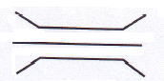

Bridge

Water falls

Quarry

Dam

Railway

Mountain peak

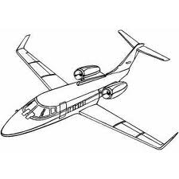 Air port

Permanent river



Rift valley

Seasonal lake

Plateau

Seasonal river

Forest

**ACTIVITY**

1. What is a map?
2. Mention one use of a map to people
3. How important is a frame as an element of a map?
4. Write any two qualities of a map
5. Mention any two types of maps
6. Mention the use of a key on a map
7. Why are symbols used on a map instead of real object?
8. Which colour is commonly used on maps to show water bodies?
9. Draw the map symbol for swamp
10. How is the symbol shown important to the people ?



**Methods used to locate Uganda on a map**

* Compass direction
* Grid reference
* Physical features
* Neighboring places

**A compass**

A compass is an instrument that is used to show direction of places while a compass rose is a drawn compass.

A compass direction is a symbol used on a map to show the direction of places.

The compass points are divided into the groups ie cardinal, semi cardinal and tertiary points.

**Cardinal points of a compass.**

These are major four points of a compass ie North, East, West and South.

North

West East

South

**Semi cardinal/secondary points of a compass.**

These are directions midway of cardinal points

They include northwest, southwest, northeast, southeast. They form 45⁰ from cardinal points. N

NW NE

W E

SW SE

S

**People who use a compass**

* Pilots
* Tourists
* Sailors
* Captains
* Mountain climbers
* Rally drivers

**How to use a compass to locate places/ country**

What is the direction of Uganda from Kenya? The person finding the direction of Uganda from Kenya should/begin from Kenya

Uganda Kenya

Uganda is west of Kenya

**Activity**

1. Name the instrument that helps a map reader to find the direction of a place……………………………………………………………….
2. Name the direction where a compass needle always points……………………
3. Name the opposite direction of North………………………………..
4. State any two semi- cardinal points of a compass ……………………………………….

**Scale drawing on the map**

A scale is the relationship of the size of map to the actual land size.

**Types of scale used on the map.**

1. **Linear scale.** This type of scale is a line divided into equal parts e.g

**0 10 20 30**

Each division shows 1CM on the map representing 10km on the ground

If Wanale is 25km a way from masindi town. How far is he on the map if the scale is that shown below.

0 5 10 1cm =5km

? = 2km

(25/5) = 5cm

1. **Statement scale.** It is given inform of words or statements.

1cm on the map represents 500m on ground

If one was travelling a distance of 20cm on the map. It means that you will be travelling (20cmx500m)

1. Representative/ fractional scale. It may be shown as a mathematical fraction e.g 1/200,000

**Island districts in Uganda**

These are districts found in lake Victoria in Uganda i.e kalangala- Buvuma

**Economic importance of kalangala district**

* These are various tourist attractions e.g Ngamba island sanctuary for chimpanzees.
* There is commercial fishing
* There is fertile soil which has favoured the growing of oil palm.

**Problems facing people in kalangala district**

* Poor transport
* Shortage of hydro- electricity
* Poor infrastructures
* Poor medical facilities.

**Solutions to the problems facing people in kalangala**

* Providing better means of water transport
* Building more schools, hospital, police stations.
* Providing ready market for products

**Uganda as a land locked country**

A land locked country is a country without a coastline or it’s own seaport.

Since Uganda is land locked, she uses the seaport of Mombasa in Kenya and port dares salaam of Tanzania to handle her overseas imports and exports.

Some neighboring countries of Uganda are also land locked ie Rwanda and south sudan.

**Problems faced by Uganda as a land locked country**

* High transportation costs
* Lack of privacy on goods
* Delayment of goods in transit
* Paying many taxes on overseas imports and exports.

**Those transport problems could be reduced through**

* modernizing agriculture to produce adequate food and raw materials.
* Promoting air transport to speed up the movement of goods
* Expanding industrialization to produce adequate goods.
* Cooperating with her neighboring countries to allow easy movement of goods.

**Uganda needs to cooperate with her neighbours in order**

* To promote foreign trade
* To promote peace and security
* To get goods she needs
* To promote free movement of people and goods
* To get market for her goods

**Importance of Uganda to her neighbours**

* She provides market for their goods
* She supplies them with hydro- electricity
* She provides both skilled and unskilled labour to them

**Uganda also benefits from her neighbours in many ways for example**

* She gets market for her goods
* She gets goods needed
* She gets exports in many fields, etc.

**Activity**

1. Name one country in East Africa that is land locked……………………
2. What is a land locked country?........................
3. Name two seaports that handle uganda’s imports and exports………………………….
4. Give one reason why Uganda should cooperate with other countries…………………
5. State any one problem faced by land locked countries………………………

**Topic two**

**Physical features of Uganda**

Physical features are land forms of the earth surface. They include plateau, hills, mountains, valley, plains, inselbergs, lakes, rivers, lowlands.

The plateau covers the largest part of Uganda

**Types of physical features**

* Relief features
* Drainage features

**Relief features.** Relief features are high land low lands of an area.

**Examples of relief features**

Hills, mountains, valley, plateau, rift valley.

**Drainage features.** These are land forms that have water in them.

**Examples of drainage features**

Lakes, rivers, streams, hot springs

**Map of Uganda showing physical features**

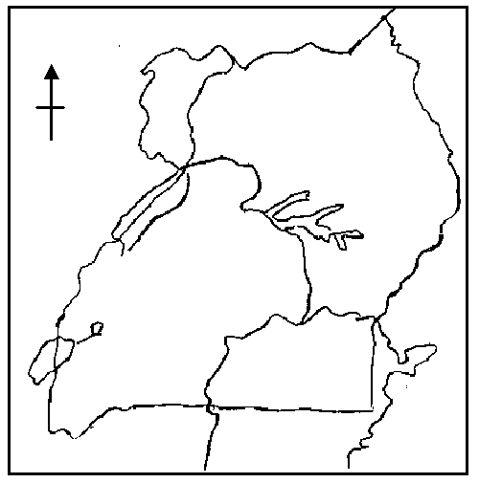

**Key**

Mountain

Rivers

Lakes

Water falls

 Rift valley

**Plateau.** This is a raised flat topped piece of land. The plateau covers the largest part of Uganda.

Lake Kyoga is the major lake found on the central plateau of Uganda.

**Economic activities carried out on the plateau of Uganda.** Fishing, farming, tourism, trade, lumbering, industrialization.

**Importance of the plateau in Uganda**

* It provides pastures for livestock farming
* It provides land for crop growing
* It promotes lumbering in forests
* It promotes fishing in lakes
* It promotes tourism
* It provides place for settlement
* It provides suitable place for industrialization

**Problems faced by human beings on uganda’s plateau**

* Pests and diseases
* Soil erosion
* Floods
* Drought

**Ways of reducing the problems**

* Spraying using insecticides
* Conserving swamps, cleaning canals and planting trees

**Activity**

1. What are physical features?...................................
2. Write any two examples of physical features in Uganda…………………………………
3. Give any two types of physical features……………………………………
4. What is a plateau?............................................
5. Which physical features covers the largest part of Uganda……………………………………
6. Name the major physical feature found on the central plateau of Uganda……………………..
7. Draw a map symbol for a plateau……………….

**Mountains in Uganda**

A mountain is a large raised piece of land higher than 2000m.

**Examples of mountains in Uganda**

* Mountain Moroto
* Mountain Elgon
* Mountain Rwenzori
* Napak
* Kadom
* Mufumbiro

**A map of Uganda showing mountains**

**Morungole**



**Moroto**

**Mt Elgon**

**Rwenzori**

**Mufumbiro**

**Types of mountain in Uganda**

* Block (host) mountain such as rwenzori
* Volcanic mountain such as Elgon, moroto and mufumbiro

**Block mountain**

* They are also called horst mountains
* They were formed by faulting
* Rwenzori is snowcapped because the peak crosses the snowline.
* Faulting is the breaking of rocks due to the pressure created inside them.
* Faults are deep crakes formed on the earth’s surface
* Forces of tension and compression led to the formation of block mountain

**Features formed by faulting**

**-**block mountains

Rift valley

Rift valley lakes

Escarpments

**Volcanic mountains**

They were formed by volcanicity or volcanic eruption.

Volcanicity is the process by which hot molten rock called magma is forced on the earth surface.

**Types of volcanic mountains**

**Active volcano.** It is the type of volcano that shows signs of eruption and can erupt at any time such as mountain mufumbiro.

**Dormant volcano.** Is the type of volcano that does not show sign of eruption but can erupt e.g mountain moroto

**Extinct or dead volcano.** Is a type of volcano that stopped erupting and can not erupt such as mountain elgon.

**Features formed by volcanicity**

* Volcano
* Crater
* Crater lakes
* Calderas
* Volcanic plugs
* Hot springs

**Formation of volcanic mountain**

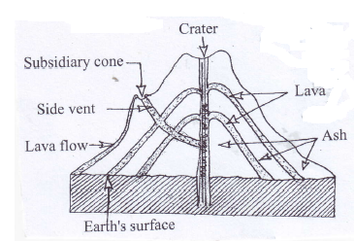

**Magma.** Is the hot molten rock below the earth’s surface.

**Crater** is a depression found on top of a volcano

**Crater lake.** Is a lake formed on top of erupt volcano

**Vent.** Is a hole through which magma passes to the surface of the earth.

**Importance of mountains**

* They have fertile soil for crop growth
* They receive reliable rainfall that supports farming.
* They act as the sources of rivers
* They have cool temperature to support human settlement

**Problems faced by people living on mountain slopes**

* Soil erosion
* Land slides
* Poor transport network
* Shortage of land due to over population
* Volcanic eruptions

**Solutions to problems faced by people in mountainous areas**

* Soil erosion
* Poor transport
* Land slides

**Economic activities carried out in mountainous areas**

* Crop growing
* Dairy farming
* Lumbering
* Tourism
* Stone quarrying
* Mining

**Rift valley**

Is a long depression found on the earth surface.

It was formed by faulting

It was due to the forces of tension and compression that accelerated faulting to occur.

It has two arms such as the eastern and western arms.

Western arms runs through Uganda

It has lakes like Albert and lake Edward.

**Map showing the rift valley in Uganda**

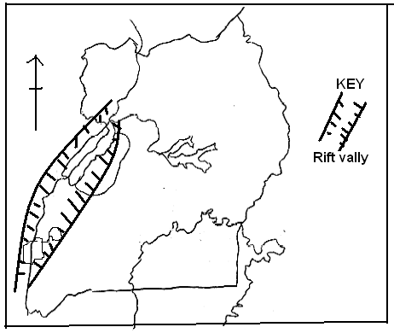

**Economic activities carried out within the rift valley.**

* Fishing
* Tourism
* Animal rearing
* Cultivation
* Mining

**Problems people in the rift valley face**

* Soil erosion
* High temperature
* Land slides
* Poor transport network

**Rivers**

Most rivers in Uganda originate from high land areas because of the reliable rainfall received through out the year.

**Types of rivers in Uganda**

* **Permanent rivers.** Are rivers that flow through out the year e.g river Nile, achwa.
* **Seasonal rivers.** Are rivers that dry up in the dry season e.g river agago

**Examples of major rivers in Uganda**

**River Nile.** The longest river in Africa

**River kagera.** Forms a boundary between Uganda, Rwanda and Tanzania.

**River semliki.** Forms a boundary between Uganda and DRC

**River achwa.** It is a tributary of river Nile in northern Uganda.

**River katonga.** Joins Lake George to Lake Victoria

River kafu

River nkusi

River mpologoma

**Stages of a river**

* Upper course/ youthful stage
* Middle course/ mature stage
* Lower course/ old stage/ semile stage

**Common terms under river**

**Delta.** Is a point where a river divides into several streams at its mouth.

**Estuary.** Is an open mouth of a river.

**Source of a river.** Is a point where a river starts flowing from.

**Mouth of a river.** Is a point where river ends.

**Tributary.** Is a small river that joins main

**Distributary**. Is a small river branching off a main river.

**Confluence**. Is a point where two or more rivers meet.

**Water shed**. Is a stretch of high lands separating different rivers.

**River load**. Materials carried by the river

**Gorge**. Is a narrow deepened valley formed by a river at its youthful stage

River semiliki and Nile form deltas at their mouth.

Rivers are politically important because they act as natural boundaries between countries.

**Activity**

1. What is a rift valley?.......................................
2. Name the process that led to the formation of rift valley…………………………………
3. Mention two economic activities carried out in rift valley…………………………..
4. Give two problems faced by the people around rift valley…………………………
5. Name the longest river in Uganda………………………………………………………….
6. How is river kagera politically important to Uganda………………………………
7. Write three the stages of rivers…………………………………………
8. Mention any four uses of river to the people………………………………………..
9. Define the following terms
10. Delta
11. Estuary………………………………….
12. Confluence………………………………
13. Mouth of a river………………………….

**Lakes**

Lakes are large volumes of water that collect in depressions on the surface of the earth

**Formation of lakes**

Lakes are formed through the following processes such as

* Faulting
* Down warping
* Volcanicity
* Man’s activities
* River deposition and meanders

**Types of lakes in Uganda**

* Depression/basin/down warped lake
* Rift valley lakes
* Volcanic lakes
* Ox-bow lakes

**Depression lakes**

They are also called basin or down warped lakes

They are formed by the process called down warping

They are characterized by having fresh water and swampy surroundings.

Examples of depression lakes in Uganda in Uganda

* Lake Victoria
* Lake kyoga
* Lake kwania
* Lake wamala
* Lake opeta
* Lake bisina

Note: lake Victoria is the largest in east Africa. It is the source of river Nile

It has in land ports like port bell and port Bukakato in Uganda.

It has fresh water.

Lake Kyoga is the most swampy lake because it is shallow.

Lake Kyoga is shallow because it experiences high rate of silting/siltation.

**Activity**

1. Name the largest fresh water lake in Uganda………………………………….
2. Mention any three types of lake in Uganda…………………………………..
3. Give any two depression lakes in Uganda……………………………………….
4. Name two inland ports found in Uganda…………………………………………
5. Which lake in Uganda is swampy………………………………………………..
6. Why is the lake swampy…………………………………………………………….
7. Mention any two importance of lake to people…………………………………

**Rift valley lakes**

* They are found within the rift valley
* They were formed by faulting

**Examples of rift valley lakes**

* Some are salty
* They are long
* They are narrow
* They have no major outlets
* They have deep water
* They have escarpments/steep sides

Lake Albert is the lake where crude oil was discovered.

It has inland ports like port Butiaba and port Ntoroko.

It has fresh waters because it has inlets and outlet.

Crude oil is found in albertine region.

Districts where crude oil has been discovered

* Hoima, Bulisa, Kibale and Ntoroko.

Lake Edward is joined to Lake George by Kazinga channel.

Most rift valley lakes have salty water because of the following.

* They lack major outlets
* They have salty rocks underneath.

Man made lakes

These are lakes formed as result of man’s activities for example by blocking the flow of a river and digging.

Kabaka’s lake is an example of a man made lake in Uganda.

**Volcanic lakes.**

These are lakes formed as a result of volcanicity

Examples of volcanic lakes

Crater lakes for example lake Nyakasuru, Nyamunuka, Katule and Muhavura.

Lava dammed lakes for example lake Bunyonyi and Mutunda.

These were formed when lava blocked the flow of the river.

Lake Bunyonyo is the deepest lake in Uganda.

Ox-bow lakes.

These are lakes formed as result of river deposition and meandering.

**Economic activities carried out around lakes and rivers**

* Fishing
* Transport
* Tourism
* Farming
* Trading

**Problems created by lakes and rivers**

* People may drown in them
* They act as breeding places for vectors
* They make road and railway construction difficult.
* They harbor dangerous aquatic animals that may attack and kill people.

**Uses of lakes and rivers to man**

* They act as fishing grounds
* They are sources of water for irrigation
* They help in rain formation
* They are used for water transport
* They have fertile soils for crop growth
* Some lakes act as sources of minerals e.g Lake Katwe.

**Problems faced by lakes and rivers**

* Dumping of wastes (pollution)
* Prolonged drought
* Silting
* Use of poor fishing methods
* Over use of swamp

**Effects of physical features on climate**

* Lakes and rivers help in rain formation
* Mountains and highlands help in rain formation
* The higher one climbs a mountain, the cooler it becomes.

**Effects of physical features on human activities**

* Mountains have fertile soils for crop growth.
* Mountains receive reliable rainfall that allows crop growth.
* Lakes and rivers act as fishing ground
* Lakes and rivers act as tourist attractions
* Plateau has fertile soil for growing crops.

**Influence of physical features on each of the following**

1. **Vegetation**

* The top of mountain is too cold to support vegetation growth
* The wind ward side of mountains receive reliable rainfall that support the growth of vegetation
* Mountains have thick vegetation due to the presence of fertile soil.
* Lake shores and banks of rivers have fertile soil and receive plenty of rainfall that supports the growth of vegetation.

1. **Animals and birds**

Around lakes and rivers, there are many birds due to the availability of water.

* Plateau has plenty of animals due to the abundant pastures for them to feed on.

1. **Human beings**

* Mountain slopes have fertile soils that allow farming by human beings.
* Lakes and rivers act as fishing grounds to human being.
* Steep slopes of mountains do not favour human settlement due to poor transport net work.

**Activity**

1. What are physical features…………………………………………
2. Why are physical features also called relief features?...........................................
3. Define these terms

a) relief………………..

b) altitude……………….

c) plateau……………….

1. Which physical feature covers the biggest part of Uganda…………………….
2. Mention the relief feature that forms a natural boundary between Uganda and Kenya…………………………………………….
3. Name the highest peak of the following mountains

a). rwenzori…………………….

b). elgon……………………

1. Name any two lava dammed lakes found in Uganda………………………………..
2. What is an island…………………………………
3. Why does river Nile flow northwards……………………………………………..
4. What is the main tributary of river Nile…………………………………..

**THE CLIMATE OF UGANDA**

Climate is the average weather condition of a place studied and recorded for a long period (30 – 35 years).

NB: Weather is the state of atmosphere of a given place for a short time.

Climatic regions of Uganda

* Tropical climate
* Equatorial climate
* Mountane climate
* Semi- arid climate

**Map showing climatic zone**

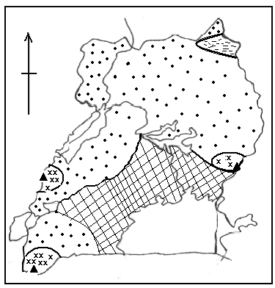

1. **Equatorial climate**

* It is described as hot and wet throughout the year.

**Characteristic of Equatorial climate**

* There are two rainfall seasons (double maxima)
* Temperatures are high throughout the year.
* Heavy rainfall is received throughout the year.
* It is mostly experienced in areas along the equator.

**Areas that experience equatorial climate**

* Shore of lake Victoria
* Wakiso
* Kampala
* Jinja
* Masaka

**Human activities carried out equatorial climate**

* Farming
* Tourism
* Hunting
* Lumbering
* Mining
* Fishing

**Crops grown in areas of Uganda which experiences equatorial climate**

* Oil palm
* Coffee
* Tea
* Cocoa
* Bananas
* Rubber
* Sugar cane

**Activity**

1. How is equatorial climate described?
2. Mention any two characteristics of equatorial climate
3. State two human activities carried out in equatorial climate.
4. Why is equatorial climate describe as hot and et throughout the year.
5. **Tropical climate**

* It is described as wet and dry
* It covers the largest part of Uganda because Uganda lies within the tropics

**Characteristics of tropical climate**

* It is wet and dry in some seasons
* Rainfall is moderate
* Temperatures are high

Table showing tropical climate

|  |  |  |  |  |  |  |  |  |  |  |  |  |
| --- | --- | --- | --- | --- | --- | --- | --- | --- | --- | --- | --- | --- |
| Month | J | F | M | A | M | J | J | A | S | O | N | D |
| Temp |  |  |  |  |  |  |  |  |  |  |  |  |
| rainfall |  |  |  |  |  |  |  |  |  |  |  |  |

**Human activities in tropical climate**

* Mining
* Crop farming
* Pastoralism
* Bee keeping

**ACTIVITY**

1. How is tropical climate described?
2. Mention any two characteristics of tropical climate
3. Identify any two human activities carried out in tropical climate
4. Name the climatic region that covers the largest part of Uganda
5. Why do most parts of Uganda receive tropical climate.
6. Mention any two economic activities carried out in tropical climate.
7. **Semi desert**

* It is described as hot and dry.

Characteristics of semi arid climate

* It is hot and dry
* Temperatures are higher throughout the year.
* Rainfall is very low.
* There is usually cold nights and hot day.

**Human activities in semi arid**

* Nomadic pastoralism
* Irrigation farming
* Mining
* Tourism

**Districts which experience semi arid climate**

* Kaabong
* Napak
* Kotido
* Nakapiripirit

**Problems faced by people who live in semi arid areas.**

* Shortage of water
* Cattle rustling
* Animal diseases

1. **Montane climate**

* It is received in high land areas of Uganda.
* Places on the leeward side receive little rainfall.
* Why – it receives dry winds
* Places of windward side receive heavy rainfall
* Why – it receives warm moist winds

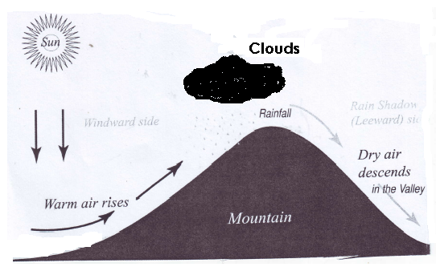

**Human activities carried out montane climatic region**

* Mining
* Quarrying
* Crop farming

**Crops grown in mountane climatic regions of Uganda**

* Arabic coffee
* Wheat
* Irish
* Bananas

**Districts that experience montane climate**

* Mbale
* Kapchorwa
* Sironko
* Kabala
* Kisoro
* Bundibugyo

**ACTIVITY**

1. How is semi desert described?
2. Mention three characteristics of semi desert climate
3. Mention two human activities carried out in

a) Semi arid climate

b) Montane climate

1. Give any two problems faced by people in; a) semi desert areas b) montane climate
2. Mention any two sides of a mountain
3. How is a mountain important in the formation of relief rainfall

**Factors that influence the climate of Uganda**

1. Vegetation cover

* Areas with thick vegetation receive heavy rainfall while areas with scattered vegetation receive little or no rainfall.

1. Relief/ Altitude

* Areas on higher altitude are cooler than those on a lower altitude.
* (The higher you go, the cooler it becomes)

1. Distance from large water bodies

* Areas near large water bodies receive heavier rainfall than those far away.

NB: convectional rainfall is received.

1. Latitude (Distance from the equator)

* Places near the equator are hotter than places far away from the equator.
* Areas near equator receive heavier rainfall than areas far away from the equator.

1. Human activities

* human activities that affect the climate positively include the following
* Afforestation
* Reforestation
* Agroforestry
* Human activities which affect the climate negatively include
* Deforestation
* Bush burning
* Industrialization

NB: - places where large forests are planted receives heavy rainfall.

* Places where people have cut down trees on a large scale receive little rainfall.

**ACTIVITY**

1. Mention any wo factors that influence the climate of Uganda.
2. How do the following factors affect the climate of an area. i). altitude ii). Latitude iii) vegetation cover iv) human activities
3. State two human ativities that influence the climate positively
4. Why is kabala cooler than arua ?
5. How does clearing of vegetation affect the climate.

**Effects of climate on people**

* Climate determines human activities and settlement
* It determines the way of dressing
* It determines the way of building

**RAIN FALL**

There are three types of rainfall

1. Cyclonic rainfall/ frontal rainfall

* It is received in plain area
* It is formed when warm moist air (winds) meets with cold dry winds at a front

front

Warm moist air cold dry air

1. Convectional rainfall

* It is received in areas around water bodies and forested areas
* It is formed when the sun heats the water body and forests causing evaporation or transpiration.
* The warm moist air is forced to rise and later condenses to form clouds that results into rainfall.

Diagram showing convectional rainfall

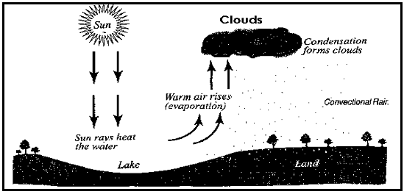

**ACTIVITY**

1. Mention three types of rainfall
2. What type of rainfall is received in mountaneous areas
3. State any two aspects of climate
4. Name the best season for harvesting crops
5. What type of rainfall is received in plain area.
6. Which aspect of climate promotes human settlement.

**VEGETATION IN UGANDA**

Vegetation is the plant cover of an area.

Elements of vegetation

* Trees
* Flowers
* Crops
* Shrubs
* Grass
* Papyrus

TYPES OF VEGETATION

1. Natural vegetation. This is the type of vegetation that grows on its on.

Examples of natural vegetation

* Natural forests
* Thickets
* Grasslands
* Swamp vegetation

1. Planted vegetation

* Planted forests
* Crops
* Planted flowers
* Planted grass

**VEGETATION ZONES IN UGANDA**

1. Equatorial / Tropical rainfalls
2. Savanna
3. Semi desert
4. Montane vegetation

**Map showing vegetation zones in Uganda**

**KEY**

**xxx Mountain Vegetation**

**Semi arid Vegetation**

**Equatorial climate**

** Tropical Climate**



1. **Equatorial vegetation**

* it is also known as tropical rainforests.
* It grows mainly along the equator.

**Characteristics of equatorial vegetation**

* Trees take long to mature
* Trees have broad leaves
* Trees have thick undergrowth
* Trees are ever green
* Trees grow tall
* Trees form canopies
* Trees have buttress roots

**Examples of Equatorial forests**

* Mabira
* Budongo
* Bugoma
* Marabigambo
* Maramagambo

**Tree species in the equatorial vegetation**

* Mahogany
* Mvule
* Rose wood
* Ebony
* Africa walnut

**Economic activities carried out in equatorial vegetation zone.**

* Farming
* Hunting
* Lumbering
* Tourism
* Mining

**ACTIVITY**

1. What is vegetation
2. State two types of vegetation
3. State four characteristics of equatorial vegetation
4. What type of vegetation grows around the shores of l. Victoria
5. State two examples of trees that grow in equatorial rainforests
6. What type of wood is got from equatorial rainforests.
7. State two economic activities that take place in equatorial rainforest
8. **Savanna vegetation**

* It covers the largest part of Uganda.
* It is found in the tropical climate region

**Characteristics of savannah**

* Trees shade off their leaves
* Trees have soft wood
* It has tall grass
* Trees have narrow leaves.

**Tree species in the savanna vegetation**

* Acacia
* Baobab

**Human activities in savannah vegetation**

* Cattle keeping
* Bee keeping
* Tourism
* Hunting
* Mining

**ACTIVITY**

1. Semi desert vegetation

* it is located in areas which receive little rainfall
* It is made up of bushes and thickets
* Much of North Eastern Uganda is made up of this vegetation.
* Trees here have thin leaves which reduces the rate of vegetation
* Cattle keeping ( pastorialism) is the major economic activity.

**Districts which have semi desert vegetation**

* Abim
* Moroto
* Kaabong
* Kotido

1. **Montane vegetation**

* It grows mainly in mountainous areas
* It changes with variant in altitude.

**Diagram showing mountain vegetation**

**Snow**

snow line

**4800m**

**Bare rock**

**4000m**

**Heath and moorland**

**Bamboo**

**3500m**

**3000m**

**Rain forests**

**Savannah**

**1500m**

**FACTORS THAT INFLUENCE THE VEGETATION DISTRIBUTION**

* Vegetation distribution is the way different kinds of plant cover are spread in an area.

**The factors that influence vegetation distribution include;**

1. Rainfall distribution

* Areas that receive heavy rainfall have thick vegetation while areas that receive little rainfall have short and scattered vegetation.

1. Human activities

* Human activities such as afforestation, agro- forestry, and reforestation promote the growth of vegetation in an area.
* Human activities such as deforestation, bush burning, swamp drainage, etc lead to poor vegetation growth in an area.

1. **Latitude**

* Areas near equator have thick and tall vegetation while areas far from the equator have short and scattered vegetation.

1. **Type of soil**

* Areas with fertile soils have short and scattered vegetation.

**Importance of vegetation**

* Vegetation attracts tourists who bring income
* It acts as a natural habitat for animals.
* Vegetation helps in rain formation
* Vegetation is source of herbal medicine
* Vegetation is a source of wood fuel
* It is a source of food
* It is a source of wood for timber

**ACTIVITY**

**WILDLIFE IN UGANDA**

* Wildlife refers to plants, animals, insects and birds that live in their natural habitats.

Categories of wild animals

1. Herbivorous. These are animals that feed on grass e.g buffalo, giraffe.
2. Omnivorous. These are animals that feed on both grass and flesh.
3. Carnivorous. These are animals that feed on flesh.

Game parks and game reserves

A game park is a large area of land gazzeted by the government to conserve wild life.

**Examples of game parks in Uganda**

* Murchison falls NP (Crocodiles)
* Queen Elizabeth NP (Hippos)
* Bwindi Impenetrable NP (Mountane gorillas)
* Kidepo Valley (Ostriches)
* Mahinga NP (Mountane gorillas)
* Mountain Elgon NP
* Mountain Rwenzori NP
* Lake Mburo NP

Game reserves in Uganda

Game reserves are areas set aside by local authorities to conserve wild life.

**Examples of game reserves in Uganda**

* Ajai
* Bugungu
* Mathemiko
* Kibale forest pian upe

**Map showing game parks and game reserves in Uganda**

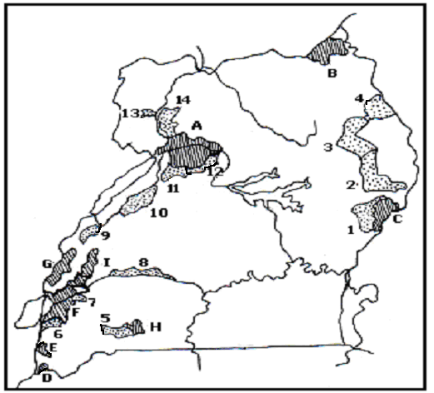

**Importance of game parks**

* They promote tourism
* Helps to preserve wildlife for future use
* It creates jobs
* They act as research centre’s
* They promote development of infrastructures

**Dangers faced by game parks**

* Poaching
* Out break of wild fire
* Encroachment
* Out break of diseases
* Prolonged drought

**Poaching**

This is the illegal hunting of animals in game parks.

**Reasons why people carryout poaching**

* To get met
* To get ivory
* To get hides and skin
* To get medicine

**Dangers of poaching**

* It leads to death of animals
* It leads to extinction of animals
* It leads to migration of wild animals

**How poaching can be controlled**

* By setting and enforcing strict laws against poaching
* Teaching people the importance of wild life.
* Employing trusted game rangers.

ACTIVITY

**TOURISM**

Tourism is the business of providing services like transport, entertainment and accommodation to people who visit places of interest for pleasure or study purpose.

**Services provided to tourists**

* Accommodation
* Transport
* Entertainment
* Security
* Medical care
* Food

**Examples of tourist attractions in Uganda**

* Climate
* Culture
* Sceneries
* Beaches
* Historical sites
* Wild life
* Hot springs
* Museum

**Factors that promote tourism**

* Good security
* Good transport
* Presence of many tourist attractions
* Improved accommodation

**Why tourism is called an industry**

* It generates income
* It creates employment

**Why tourism is called invisible export**

* It generates foreign income yet no physical goods are taken out side the country.

**Examples of invisible exports**

* Tourism
* Electricity
* Skilled labour
* Insurance

**Importance of tourism**

* It earns income
* It creates jobs
* It improves on infrastructure
* It creates market for locally made good.

**Problems facing tourism industry**

* Poaching
* Poor transport network
* Insecurity
* Poor accommodation

**Solutions to the problems**

* Improving on security
* Advertising tourist attractions on international media
* Enforcing laws against poaching
* Improving on infrastructure

**NATURAL RESOURCES IN UGANDA**

A natural resource is anything in the environment that man uses to satisfy his needs and exists on its own.

Types of natural resources

a). renewable resources. These are resources that can be replaced naturally after use.

Examples

* Plants, animals, land, climate, water.

b). non renewable resources. These are resources that can not be replaced naturally after use.

Examples

* Minerals

**Minerals**

These are valuable substances found in the underground.

Types of minerals

* Metallic e.g copper, gold, cobalt
* Non metallic e.g salt, lime stone, sand
* Fuel minerals e.g crude oil, natural gas.

**Minerals mined in Uganda**

|  |  |  |  |
| --- | --- | --- | --- |
| minerals | Area/place | district | product |
| Lime salt | Usukuru hills  Hima | Tororo  Kasese | Cement |
| Natural gas | Albertine region | Hoima  Bulisa | Gas |
| Phosphate | Usukuru hills | Tororo | Artificial fertilizers |
| Salt | Lake katwe | Kasese | Common salt |
| Crude oil | Albert region | Hoima  Bulisa | Petrol  Diesel  Kerosene |

**Mining**

Mining is the extraction of minerals from where they exist.

Methods of mining

* Open cast
* Drilling method
* Underground mining

Reasons why some minerals are not mined

* Low technology
* Shortage of skilled labour
* Lack of modern machinery
* Shortage of capital.

**ACTIVITY**

**LAND**

Land is the surface of the earth that is not water.

Reasons why land is considered as the most important resource.

* Most resources are found on land
* Most economic activities are carried out on land.

**Uses of land**

* For farming
* For mining
* For settlement
* For road construction

**Land degradation**

This is the lowering of quality of land

Ways of degrading land

* Over grazing
* By deforestation
* By brick making
* By bush burning
* By over mining

**Land conservation**

This is the practice of protecting land against degradation

Ways of protecting land

* By afforestation
* Re- afforestation
* By agro- forestry
* By bush fallowing

**ACTIVITY**

**PEOPLE**

They are referred to as resources because they provide labour.

Forms of human labour

* Skilled labour
* Semi skilled labour
* Un skilled labour

Water as a resource

Water is got from the following sources.

* Rain
* Lakes
* Rivers
* Swamps
* Streams
* Tank

The main economic activity carried out on water bodies is fishing.

Fishing

Fishing is the catching of fish from water bodies

Commercial fishing is on the rise in Uganda today due to an increase in demand for fish and its products.

**Traditional methods**

* Use of spears
* Use of fishing baskets
* Use of hooks
* Use of local herbs
* Use of fishing rods
* Use of bows and arrows

**Modern method**

* Use of fishing nets
* Use of trawling
* Use of drifting method

**Reasons why modern methods are used on large water bodies.**

* To catch a lot of fish at ago
* Presence of deep water
* To preserve young fish species
* They are easy and effective to use.

**Examples of fish species caught in Uganda lakes**

* Tilapia (commonest)
* Nile perch (the largest)
* Mud fish (commonly in swamps)
* Lung fish

**Modern methods of fish preservation**

* Tinning (canning)
* refrigerating (freezing)
* deep frying

**Traditional methods of preserving fish**

* smoking (commonest)
* sun drying (cheapest)
* salt

**Uses of fish to man**

* source of food
* it is a source of employment
* fish bones are used to make animal feeds

**Problems facing fishing industry**

* poor transport net work
* poor fishing method
* shortage of storage facilities
* water weeds
* Piracy.

**Solution**

* by constructing better roads to landing sites
* by enforcing laws against poor fishing methods
* by providing fishing storage facilities

**ACTIVITY**

**Problems created by natural resources**

* death
* attacks from wild animals
* collapsing of mining sites

**How people misuse resources**

* through poor disposal of wastes
* through over cultivation
* through bush burning
* through over grazing
* through deforestation

**How people care for natural resources**

* through watering
* through spraying plants
* through immunizing animals
* through cleaning water sources
* through fencing water sources

ACTIVITY